***DryHireUK   
Dehumidifier Hire for :***

* ***Drying out flood damaged rooms .***
* ***Drying Damp or mouldy areas***
* ***Humidity control for prevention of corrosion in metal structures***
* ***Quicker drying times in construction materials such as concrete.***
* ***Controlled environments floor laying***
* ***Reduces costs due to condensation damage***
* ***Humidity control for work environments such as:  
  Hairdressing salons  
  Swimming pools and spa  
  Pub cellars***

***At DryHireUk we carry a range of Dehumidifiers and Building drying solutions to reduce and  
control humidity in a variety of different environments from domestic to commercial .  
 Using Building dryers and dehumidifiers is an efficient way of Controlling damp conditions and removing moisture after flooding or dampness due to our inclement weather systems .   
Our portable , commercial grade systems are easy to setup up and operate and can be delivered to your door.***

***Choose between our range of units and order online or give us call and we can help decide on the right equipment for your requirements.***

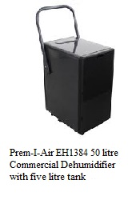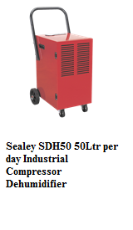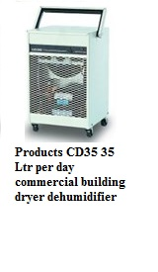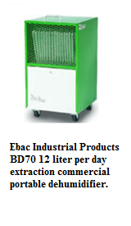

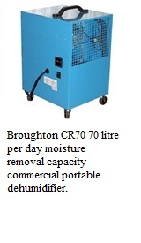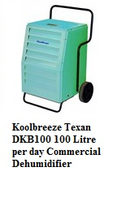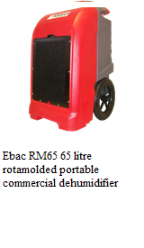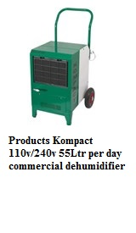

***24/7 Delivery   
Competitive rates   
New High performance Building dryers for flood damage.***

***Contact us now on :***

***TEL: 0117 9095727***

***Mob: 07903801031  
Mob:*** **07966 487504**Web: **www.dryhireuk.com**